Question 1: Code with screenshot

function CheckPalindrome(str){

var count=0;len=str.length;

for(i=0;i<str.length;i++)

{

if(str[i]===str[len-1])

{

count++;

len=len-1;

}

}

if(count===str.length)

{

console.log("YES palindrome");

}

else

{

console.log("NOT Palindrome");

}

}

var result=prompt("Enter A String:");

console.log(CheckPalindrome(result));

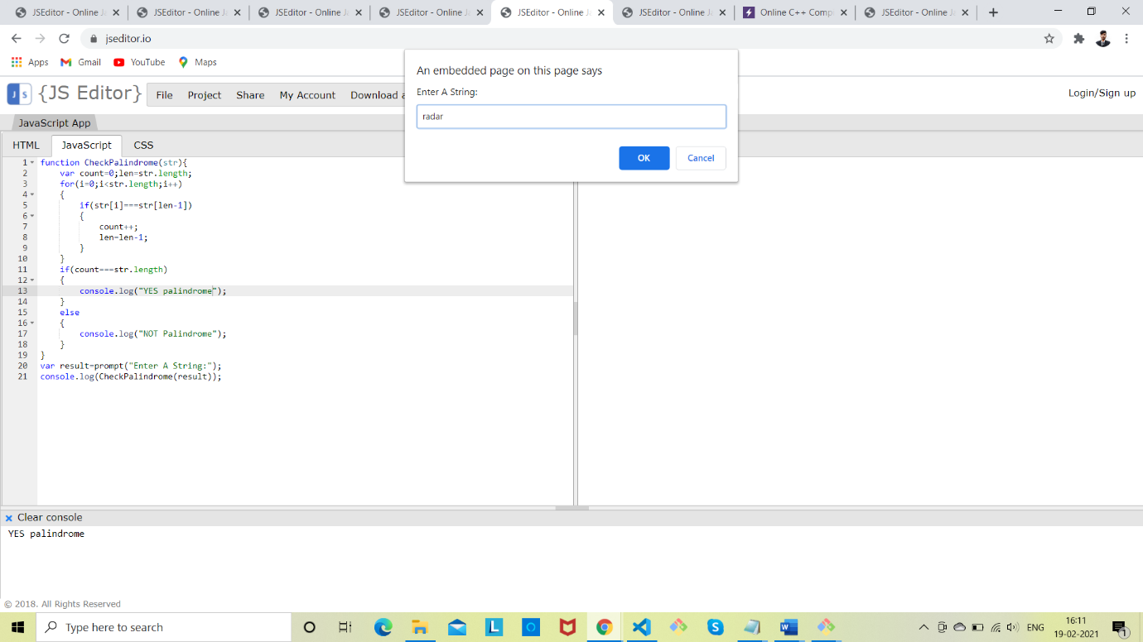

Question 2: Code with Screenshot

var n=prompt("Enter any no.");

for(i=n;i>=1;i--)

{

if(i%2==0 || i==1)

{

for(j=n;j>=i;j--)

{

document.write(j+" ");

}

document.write("<br>");

}

}

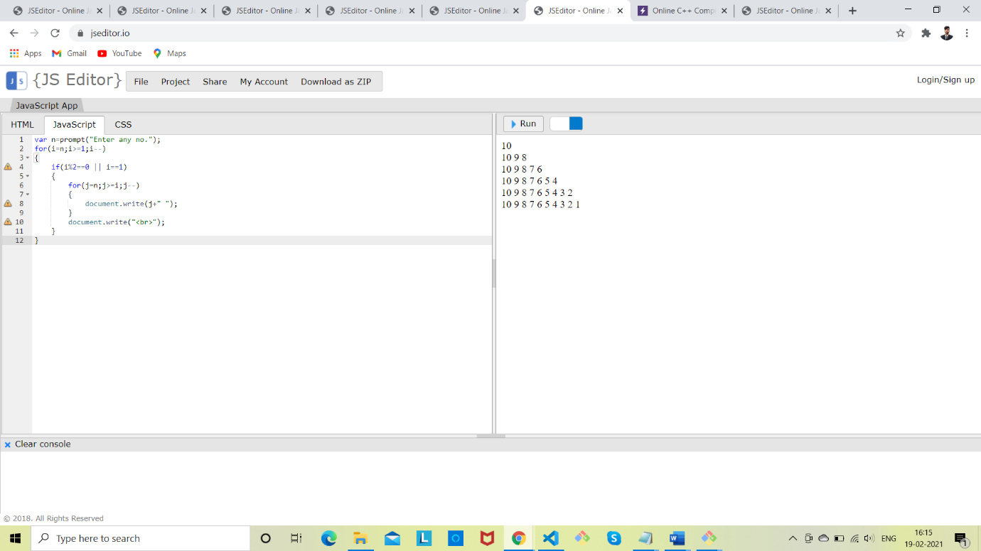

Question 3: Code with Screenshot

var n=parseInt(prompt("Number:"));

for(i=0;i<n\*2;i++)

{

for(j=1;j<=n\*2;j++)

{

if(i<n)

{

if(j<=n-i||j>n+i)

{

document.write("\*");

}

else{

document.write("&nbsp&nbsp");

}

}

else{

if(j<=i-n+1 || j>=((n\*2)-(i-n)))

{

document.write("\*");

}

else{

document.write("&nbsp&nbsp");

}}}

document.write("<br>");

}

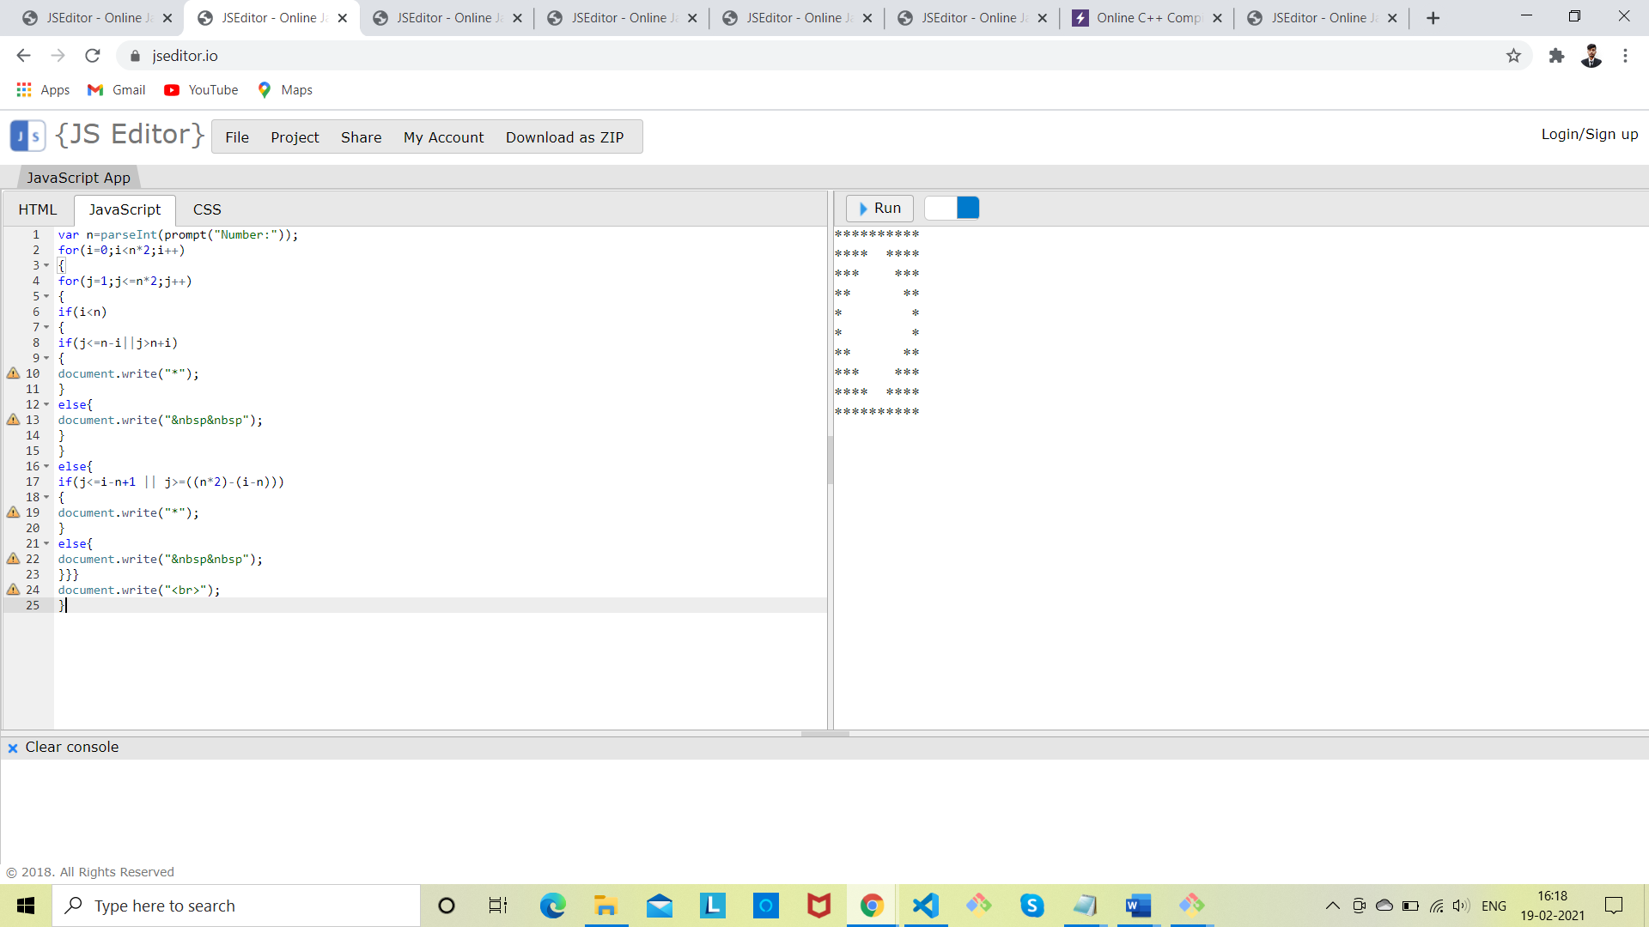

Question 4: Code with Screenshot

#include<stdio.h>

int main()

{

int i,j,k=0,rows,n;

printf("Enter the number of rows");

scanf("%d",&rows);

n=(rows+1)/2;

for(i=1;i<=rows;i++)

{

i<=n?k++:k--;

for(j=1;j<=rows\*2;j++)

{

if(j>=n+1-k&&j<=n-1+k)

printf("\*");

else

printf(" ");

}

printf("\n");

}

}

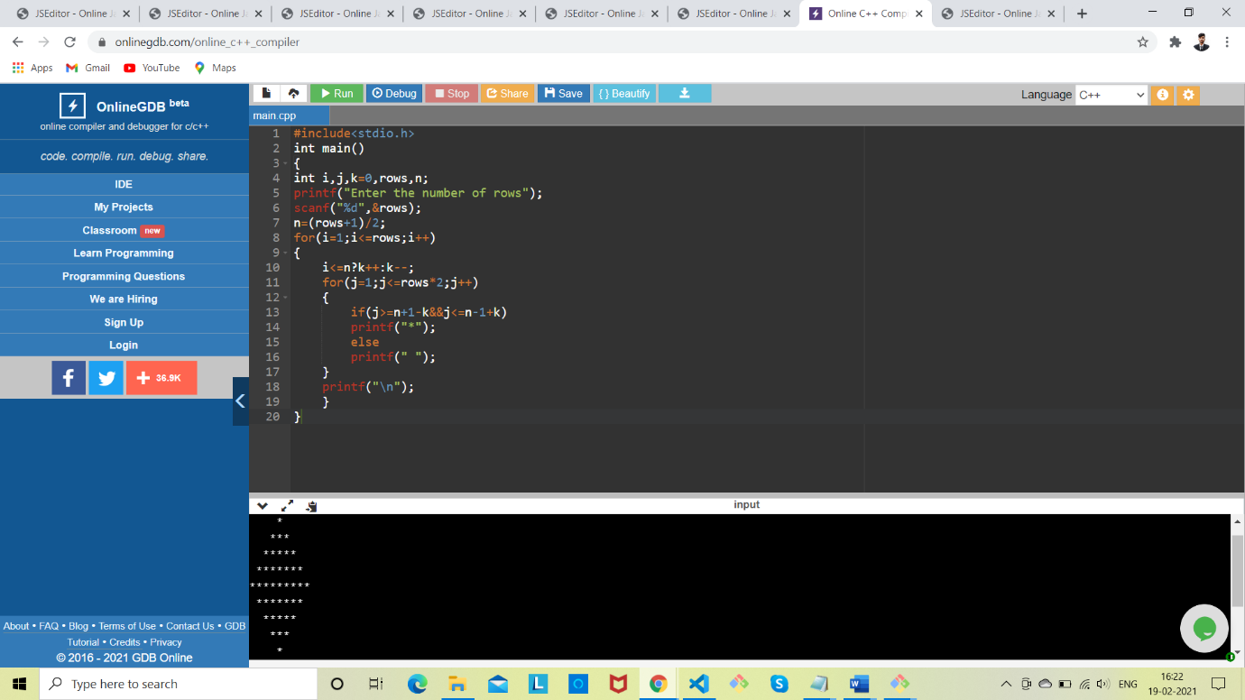

Question 5: Code with Screenshot

var n=prompt("Enter any Number");

for(var i=0;i<n;i++)

{

for(var j=0;j<=i\*2;j++)

{

document.write(String.fromCharCode(65+Math.abs(i-j))+'&nbsp');

}

document.write("<br>")

}

for(i=n-2;i>=0;i--)

{

for(j=0;j<=i\*2;j++)

{

document.write(String.fromCharCode(65+Math.abs(i-j))+'&nbsp');

}

document.write("<br>")

}

